**How to get to my school‘s results?**

1. On the Happy School page click on the "Results" button and you will be redirected to the Dropbox page. Click on File 🡪 Download.

Paveikslėlis, kuriame yra tekstas, programinė įranga, skaičius, Šriftas

Automatiškai sugeneruotas aprašymas

1. The table below will pop up. You have to select the option "Or continue with download only" at the bottom.

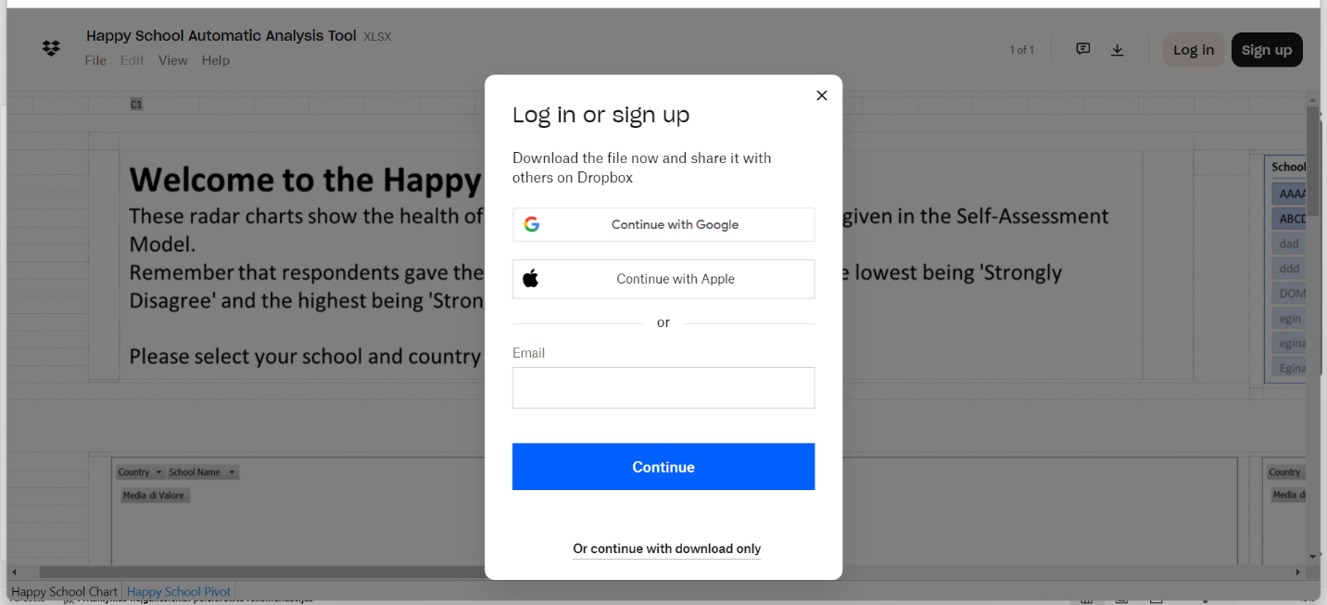

3. The Excel file with the results has already been downloaded to your computer. Open this file and allow all flags that excel asks for.

4. Wait 3-5 minutes for all data to load and then filter the data using the filter fields (Country - select Italy; School name - select your school code). The filter fields can be found in the graph box (marked in red).

Paveikslėlis, kuriame yra tekstas, programinė įranga, Kompiuterio piktograma, diagrama

Automatiškai sugeneruotas aprašymas

Wish You good luck,

Happy School team